Artist Collective Representative Letter
City
Date
Regarding: Designating Legal Representative / Collective Liason

Call for Entries: 8th Edition of the Border Bienial 2026
Attn: Committee Organizers
By way of this communication, those individuals that comprise the artistic collective known as______________, we manifest our voluntary group participation in the 8th Edition of the Border Bienial 2026. This document establishes that members of the collective have agreed to its representative:
Name of Representative: [Complete name of Liason]
Official ID number ¹: [Identification Number]
The Representative is the sole indivdidual responisble before the Biennial, with the authority to:
Sign submission docoments and the understandign of terms.
- Coordinate shipping, installation, and return of artwork.
- Receive official notifications, and coordidate the distributino of any payments or awards as a result of the Collective’s particiaption in the Biennial. Los integrantes del colectivo aceptamos que cualquier comunicación o acuerdo realizado con el/la representante arriba mencionado(a) tendrá validez para todo el grupo.
Members of the Collective accept that all Communications with the Representative listed above will be recognized as as official communicaitons with the Collective.
Member signatures:
Full Name Document Identfication Signature
__________________________ _____________________________ ___________________
__________________________ _____________________________ ___________________
__________________________ _____________________________ ___________________
__________________________ _____________________________ ___________________
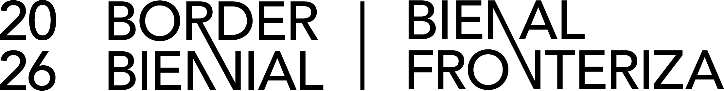
__________________________ _____________________________ ___________________

1. Requirement applicable only to Mexican citizens.

