Letter of Participation

City:
Date:
Attention: Organizing Committee of the 8th Edition of the Border Bienniel 2026

To Whom It May Concern:
By means of this document [INSERT NAME OF ARTIST OR COLLECTIVE REPRESENTATIVE] identified with the document ID¹ [INSERT ID NUMBER] I manifest my voluntary participation in the 8th Border Biennial 2026 with the workis titled [INSERT LIST OF WORKS SUBMITTED].
I declare the following is true:
- Acceptance of Terms: I have read, comprehended, and understoon in its totality the terms, conditions, and requirements established in the official Biennial Call for Entries.
- Authenticity: I declare the works of art presentated here are my creation (or that of a collective I represenent), and that these works are origigal and that I hold all rights to the artwork and its intellectual property.
- Availabilituy: I commit to meeting the shipping deadlines in the case my works are selected.
- Image Rights and Reproductions: In the case my works titled [INSERT TITLES HERE]__________________________ is selected, I authorize the organizing parties to present, distribute and reproduce my submissions in any medium, so long as its exclusive purpose is to promote and market this cultural program and that it be done withot commercial benefit as the use of the images are not for commercial purposes. Considering the above, I hold exclusive rights to my work along with a correspondign image credit.
I hold harmless the organizers from any claims from third parties about the authorship of the submitted works.
Sincerely,
[ARTIST SIGNATURE OR LEGAL REPRESENTATIVE]

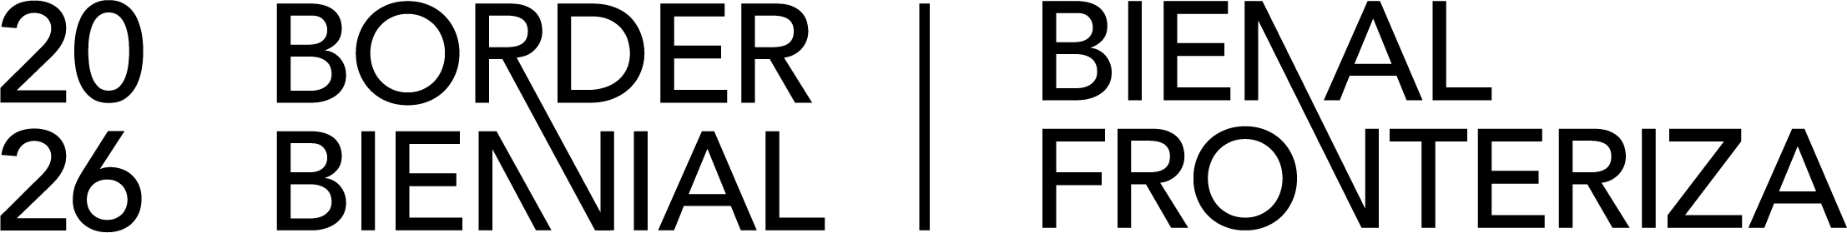
1. Requirement applicable only to Mexican citizens.

